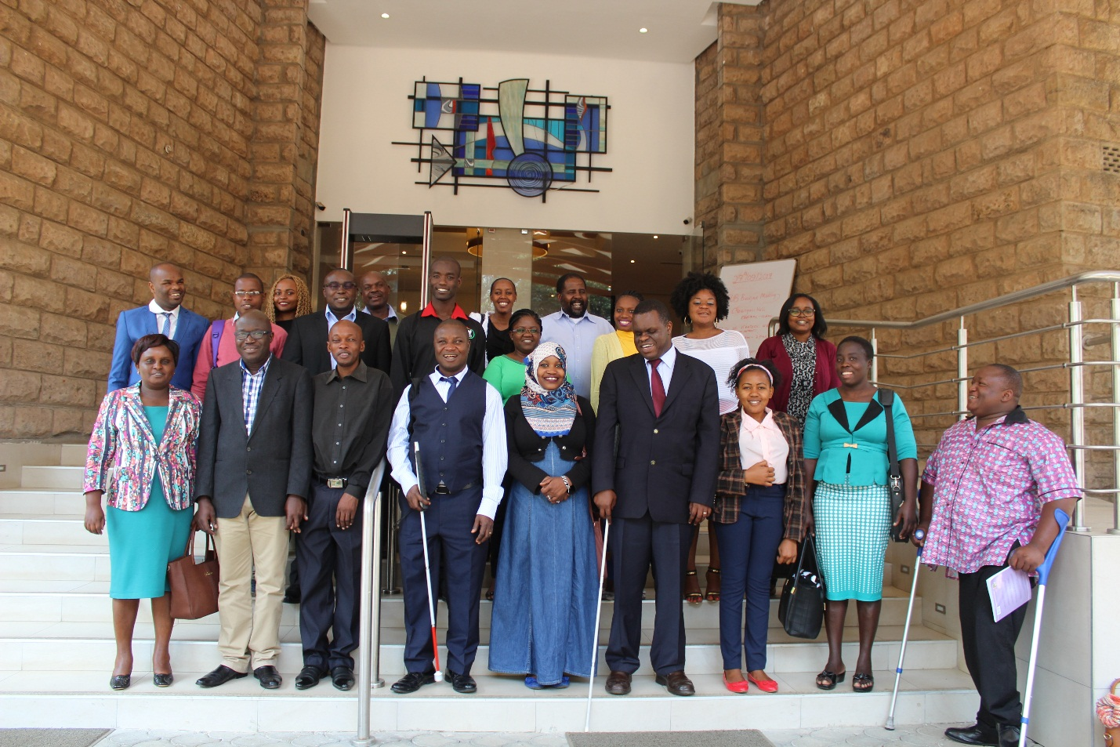
Participants of the ARADI prelaunch at Hillpark Hotel, Nairobi

PRELAUNCH OF THE ARADI PROJECT

On the morning of September 27th, 2017, over 20 persons from several Disabled People’s Organisations, DPOs and other stakeholders stepped away from their offices and various commitments to take part in a ground-breaking event: “The Prelaunch of the ARADI Project”.
The participants were treated to a sumptuous breakfast at the Hillpark Hotel in Nairobi, while listening to presentations on the ARADI project.

Alliance for Rights – Africa towards Disability Inclusion (ARADI) is a three year project aimed at enabling civil society organisations and Pan-African disability federations to participate and contribute to key African Union decisions, policies and laws related to human rights and persons with disabilities.
The African Union of the Blind, AFUB is implementing ARADI in partnership with the Africa Disability Alliance, ADA. In its initial six months spanning July to December 2017, the partnership seeks to launch advocacy activities in Kenya towards the adoption of the African Disability Protocol (ADP) and the Model Disability Law (MDL). The ADP complements the African Charter on Human and Peoples’ Rights and addresses continued exclusion, harmful practices, and discrimination affecting persons with disabilities, especially women, children, and the elderly.

Among the participants at the prelaunch was none other than Commissioner Lawrence Mute who played an instrumental role in the development of the draft protocol and he remarked that ‘AFUB plays a critical role on the continent and should benefit from all our support’.
Also represented at the prelaunch were United Disabled Persons of Kenya (UDPK), Ecumenical Disability Advocates Network (EDAN), Voluntary Services Overseas (VSO), Kenya Union of the Blind (KUB), Nairobi Family Support Services (NFSS), Embrace Inclusion, Action Network for the disabled (ANDY), Kenya Association for the Intellectually Handicapped (KAIH), Standard Chartered Bank, Handicap International and the University of Nairobi (UoN).

While awaiting the African Union to open the ADP for ratification, hopefully in early 2018; AFUB intends to work with all DPOs present at the breakfast meeting as well as the earlier established Kenya ARADI Campaign Team and various other stakeholders to create awareness within the country on the ADP and MDL; seek the commitment of the Kenya government to adopt the ADP when it is open for ratification; and seek the commitment of embassies of African countries based in Kenya to encourage their governments to adopt the ADP.
The African Disability Protocol will enter into force once 15 countries have ratified it. The task ahead is no minor one, so: LET THE WORK BEGIN!

